Using UFCOM driver (USB-Serial) with M430 scanner

Using HID interface for the FM408 (2 scanners in single application)

Goal: prove that the Newland FM430 scanner can work using USB COM port emulation mode using the UFCOM serial port driver, and simultaneously use the FM408 in HID mode (no driver required for HID Mode)

The FM408 should remain in HID mode as programmed by TokenWorks, the FM430 will be programmed to: USB COM Port emulation and requires the UFCOM driver to be installed on the PC

Step1: Install the UFCOM driver from newland onto your PC:

https://www.newland-id.com/en/services/software-drivers

Step2: with a properly registered M430 scanner from TokenWorks, plug the scanner into the PC’s Usb port and the barcode programming codes from Newland. These codes were obtained from the NLS-FM420 Quick Start Guide

Scan the barcode called “Code Programming On”
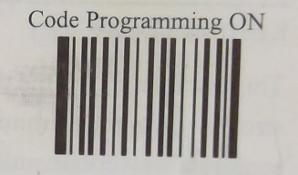

Scan the barcode called “Select USB COM Port Emulation”

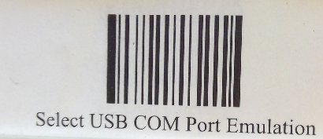

Scan the barcode called “Code Programming Off”
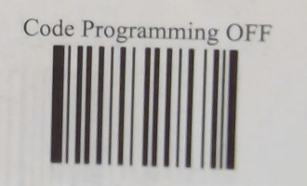

NOTE: If you device will not read the barcodes off the screen, it is suggested that you print this document out on paper, and reduce the image size of the individual barcodes, prior to printing.

Step3: open device manager to verify your PC is recognizing the scanner properly:

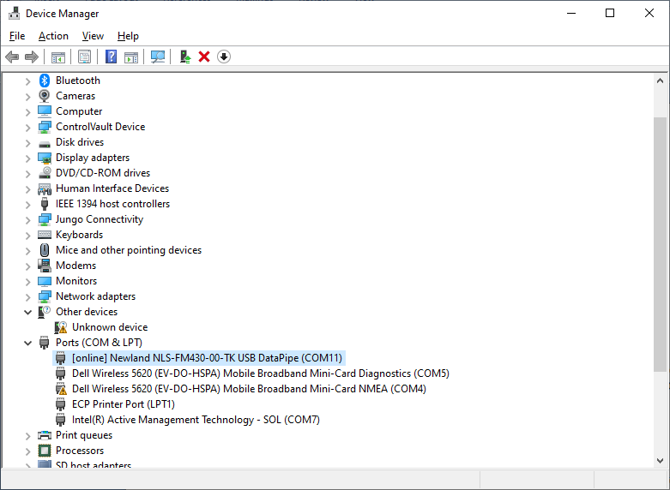

We can find the FM430 under Ports (COM & LPT) as COM11

When both the COM port scanner (FM430) and the HID scanner (FM408) are connected, the device manager should appear like this:

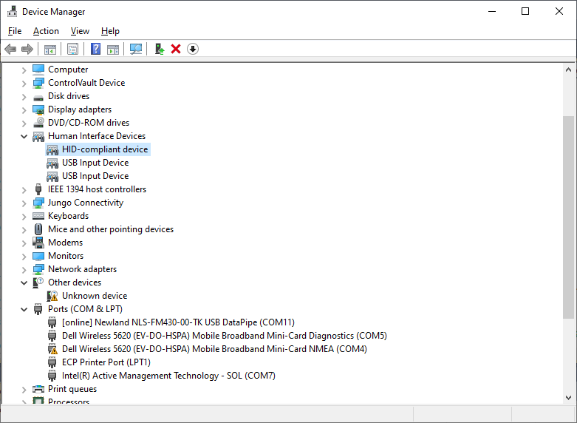

The HID-Compliant device is the FM408, the FM-430 is found under Port (COM & LPT)

IF you do not see an HID-Compiant Device, then you probably have a POS scanner entry, in this case you must change the update the driver on the POS Scanner.

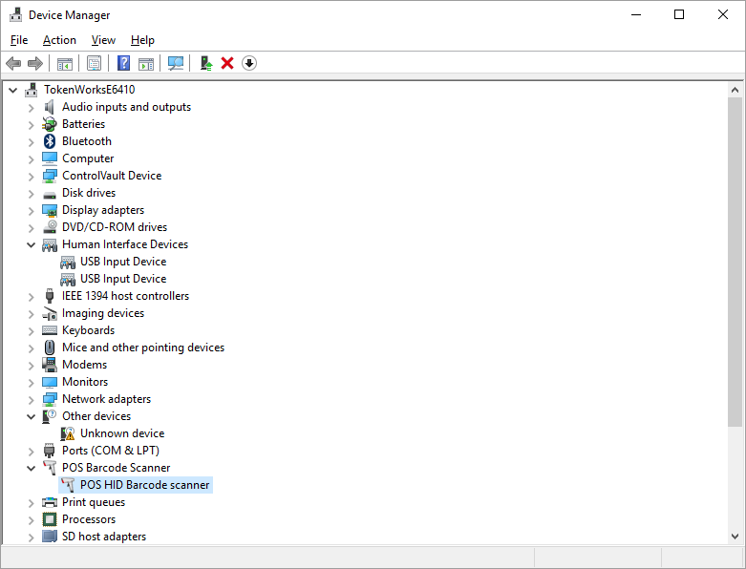
If you see the POS Barcode entry for your HID scanner, follow these instructions to switch to the HID-Compliant device:

First: right click the POS Barcode icon in Device manager and select: Update driver
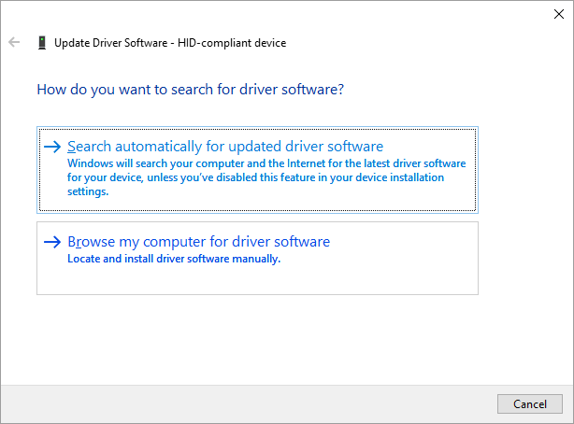
Next: select Browse my computer for driver software
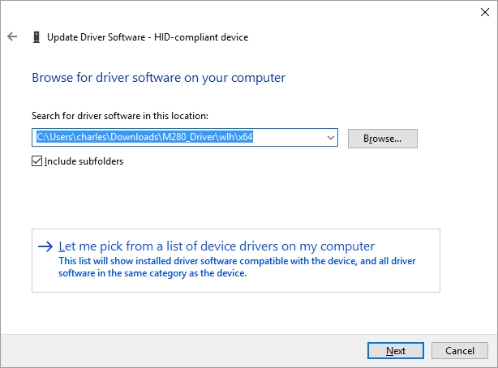

Then:Select Let me pick...
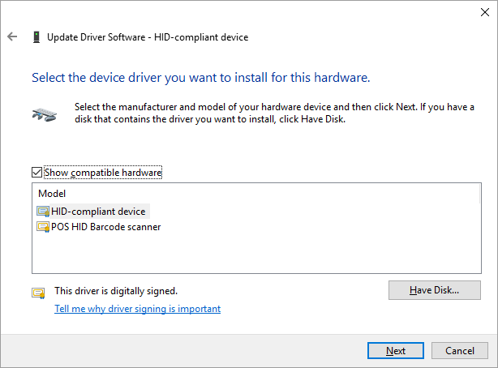
Finally: select the HID-compliant device.

The Device Manager should now appear as:
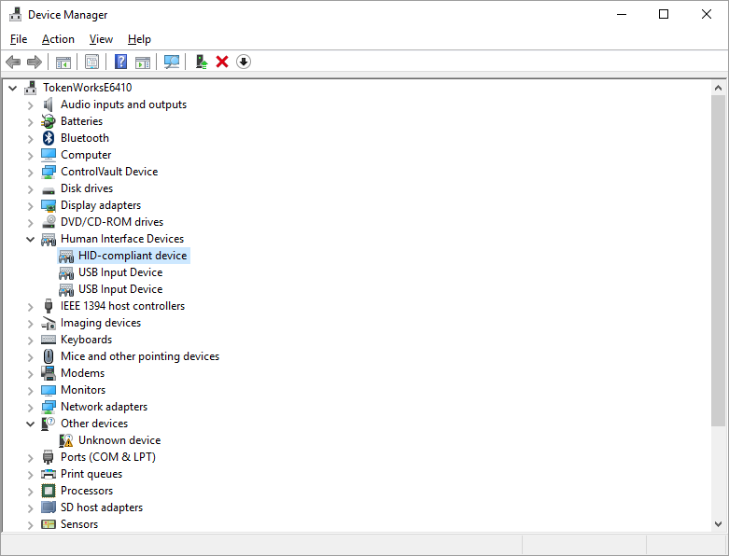

We see the HID-Compliant Device, instead of the POS-Barcode entry.

Appendix

To restore the scanner back to its original configuration as an HID -Compliant scanner you will need to scan the following code:

Scan the barcode called “Code Programming On”

Scan the barcode called Hid-Pos
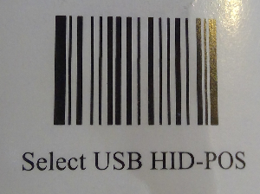

Scan the barcode called “Code Programming Off”

Verify the scanner is Hid Compliant by using the Device Manager

End of Document

